**Docker Task**

**Task Description:**

Install docker on EC2 and explore the docker commands (docker images, containers, volumes, network)

**Install Docker**

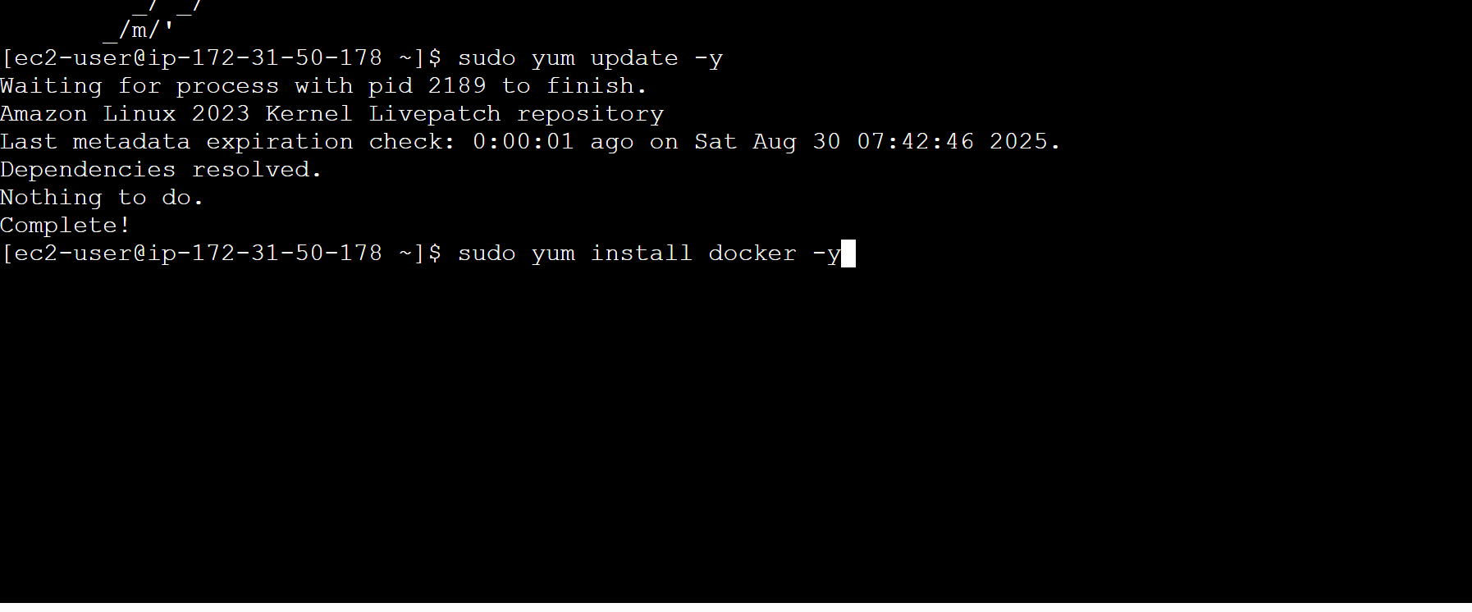

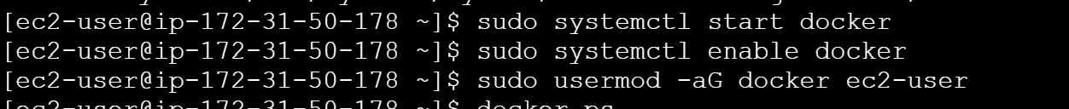

*sudo usermod -aG docker ec2-user*

*sudo: Runs the command with* ***superuser privileges****.*

* *usermod: Modifies a user account.*
* *-aG docker: Adds the user to the* ***docker group*** *(-a = append, -G = group).*
* *ec2-user: The default user on Amazon Linux EC2 instances.*

**Docker Images & Containers**

Pull nginx image and run container in detached mode

*docker images # List local images*

*docker pull nginx # Download image from Docker Hub*

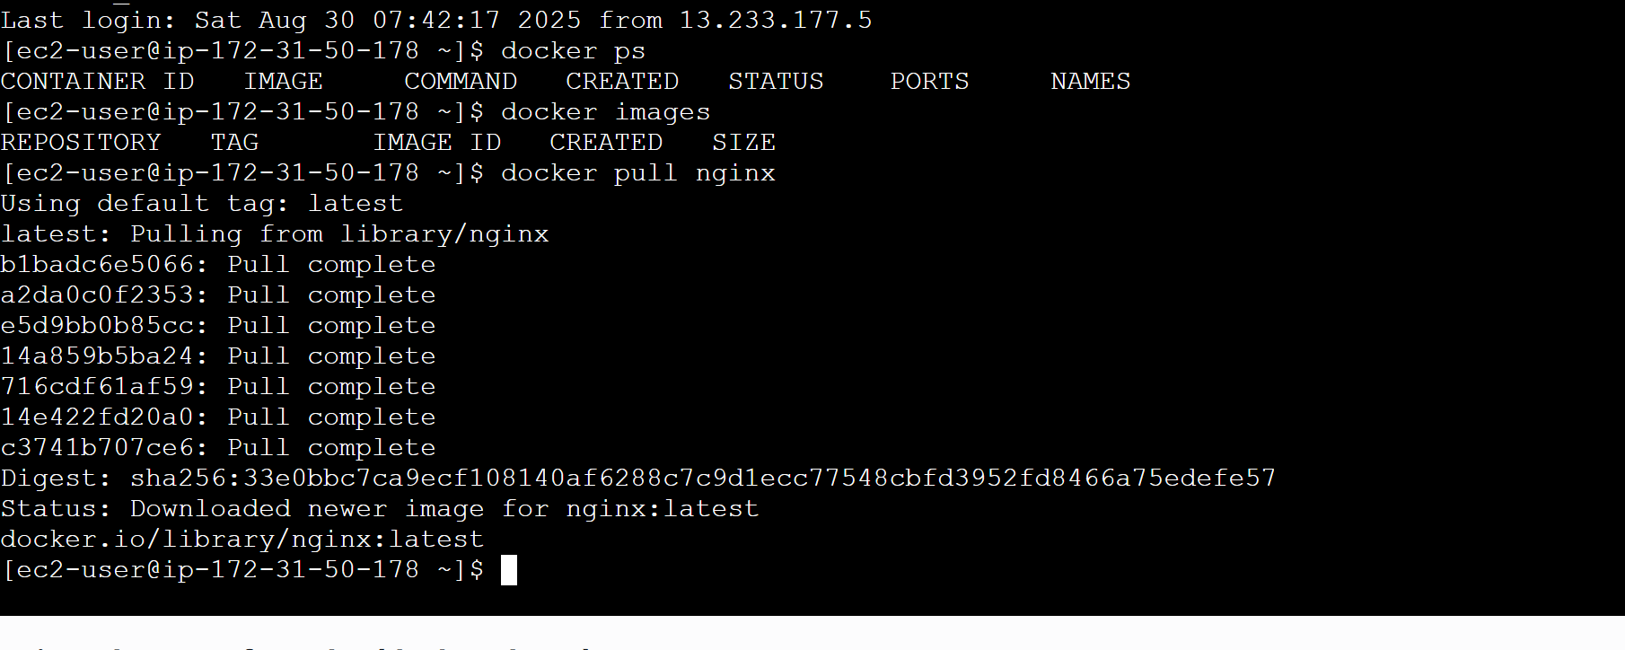

*docker run -d -p 8080:80 nginx # Run container in detached mode*

*docker ps # List running containers*

*docker ps -a # List all containers*

View the file in browser using public IP

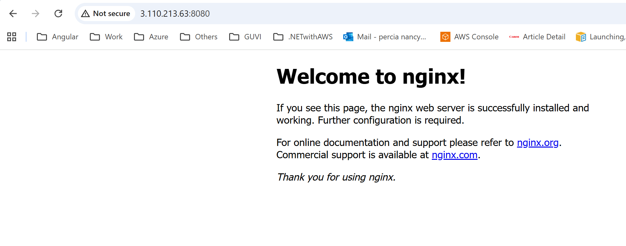

**Docker volumes**

*docker volume create mydata # Create volume*

*docker volume ls # List volumes*

*docker volume inspect mydata # View volume details*

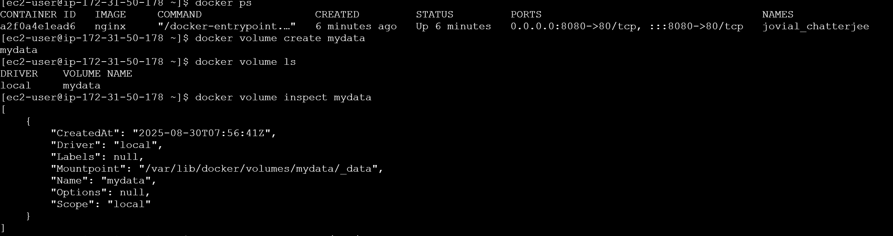

Write a file inside the container to test persistence

docker exec -it <container-id> sh

echo "Hello from Percia!" > /app/data/test.txt

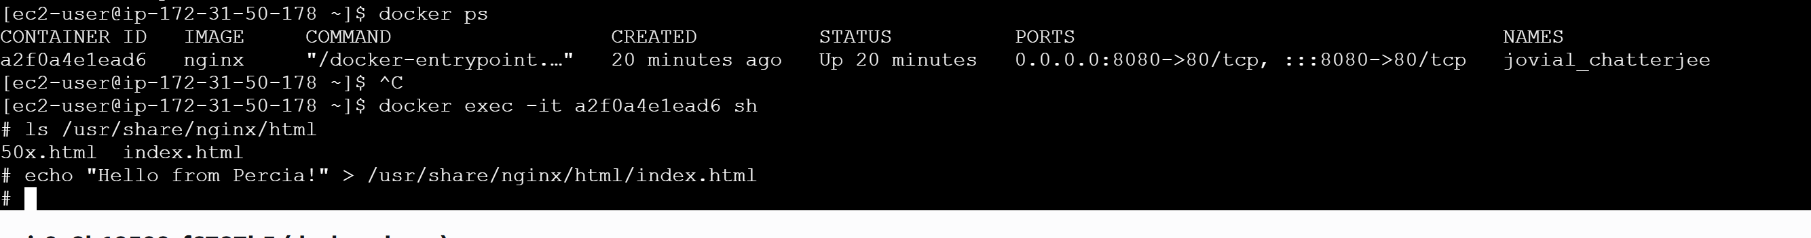

View the modified file in browser

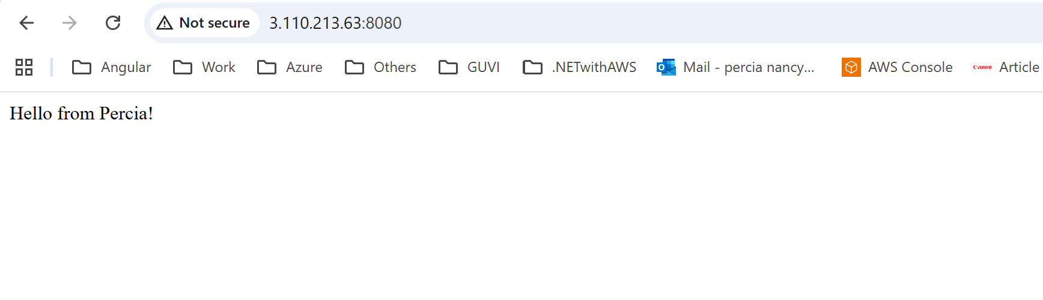

**Docker Network**

*docker network ls # List networks*

*docker network create percianet # Create custom network*

*docker network inspect bridge # Inspect default network*

